This is an Accomplishment Based Renewal Proposal:
Considerable progress has been made over the past granting period in the development and applications of new olefin metathesis catalysts. We propose to continue the development of new catalysts that are more stable and selective. As in the past, new capabilities will open an array of new applications. In addition to the new systems developed, new rapid methods will be developed for the assessment of catalyst properties and capabilities. New polymer structures will be prepared allowing new theories on structure-property relationships to be developed and tested. A new area of research will be initiated that is designed to find new catalysts for interesting processes. The strategy is based on the transfer of functionality between olefins- functional group metathesis- and will rely on the combination of basic mechanistic studies and rapid screening techniques.

New NHC ligands and Catalysts for increased stability and selectivity.
Key to recent advances in metathesis has been the discovery of new ligand systems that open unprecedented reactivity. Novel methodologies are being developed to prepare the appropriate ligands. New catalyst systems prepared from these ligands will be tested in our standard array of test substrates. We have recently developed rapid and efficient strategies for the measurement of catalyst stability using our Symyx robot system. Initial results indicated that with further development the system will allow a full screening of the capabilities of all catalysts with minimum effort by the researchers. The arrays of data produced in this way will allow for many subtle features of the catalysts to be uncovered.

New routes to NHC complexes
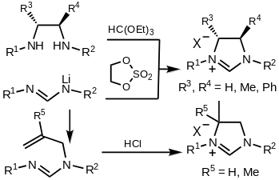
The use of saturated N-heterocyclic carbenes (NHCs) as ligands in ruthenium-based olefin metathesis has allowed for great gains in both activity and stability. Amongst the different ways to prepare free NHCs, the deprotonation of the corresponding saturated imidazolinium salts (NHC,H⁺) is the most widely used. The method of choice towards these salts is the reaction of triethylorthoformate with the corresponding diamine. Unfortunately, this approach suffers several drawbacks: the preparation of the diamine includes either a palladium C-N coupling or a reduction; moreover, several desirable substitution patterns are difficult to synthesize. Recently, Bertrand et al. envisaged an alternative retrosynthetic disconnection and showed that the addition of a lithiated formamidine to “di-electrophiles” such as 1,3,2-dioxathiolane-2,2-dioxide led to the desired cyclic salts in high yields. They also showed that NHC,H⁺ could be accessed by hydro-amidiniumation of an alkene. (This last sentence doesn’t seem necessary for the rest of the proposal)
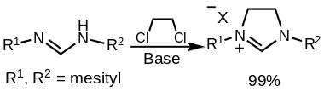
Improved route: Following Bertrand’s report, we reasoned that imidazolinium chlorides could be prepared directly from the reaction of formamidines with dichloroethane in the presence of a base. For example, when dichloroethane was reacted with N,N’-dimesitylformamidine in the presence of a base, the NHC,H⁺ was obtained in almost quantitative yield. This new solvent free method should allow for the facile preparation of symmetric and unsymmetric saturated imidazolinium chlorides without requiring lithiated formamidines.
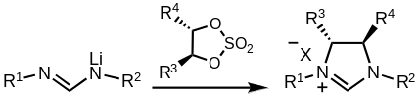
Chiral salts: Until now, the preparation of chiral imidazolinium salts has been limited by the availability of enantiopure diamines and the efficiency of the Pd C-N coupling that introduces the N-aryl groups. By reacting disubstituted chiral cyclic sulfates with lithiated formamidines, the preparation of chiral NHC,H⁺ would be considerably more facile. The ready availability of chiral cyclic sulfates, and both symmetric and unsymmetric formamidines, suggests this new method should provide a wide variety of previously unknown chiral ligands.
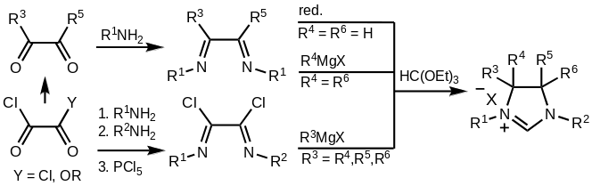
Backbone substitution: One of the main modes of decomposition in ruthenium based olefin metathesis catalysts is the C-H activation of the N-aryl substituents. As part of our continued efforts to increase the stability, and thereby efficiency, of these catalysts, we are pursuing a number of approaches to prevent rotation about the N–aryl bond, which precedes the irreversible C–H activation step. We proposed that these decomposition modes could be limited by substitution on the backbone. Moreover, Jensen et al. calculated that highly substituted NHCs could increase the activity of the ruthenium olefin metathesis catalyst. Although unexplored, these compounds can be prepared by multiple additions to a bis-imine. An introductory series of these complexes has been prepared and initial studies revealed interesting reactivity from substituted NHCs A full series of methyl, ethyl and phenyl compounds will be prepared to further determine if complexes containing such ligands show enhanced stability.
Another approach is the covalent linkage of the N-aryl substituent to the backbone of the NHC ligand. Based on molecular modeling studies, we targeted NHC ligands with a trimethylene? tether. This tether would prevent the aryl ring from approaching the ruthenium center, thereby preventing this mode of catalyst decomposition. Additionally, comparison of catalysts containing either the cis- or trans-linked NHC ligands would provide information about the effects of steric bulk around the active ruthenium center.
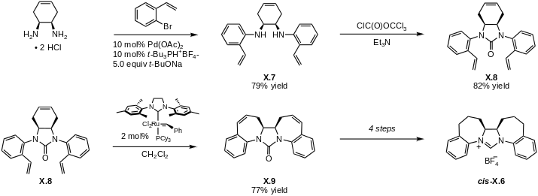
Preparation of the corresponding cis-linked NHC ligand (cis-X.6) begins with Buchwald-Hartwig coupling of cis-1,2-diaminocyclohex-4-ene with 2-bromostyrene to afford tris(olefin) X.7. The diamine functionality in X.7 was masked by conversion to urea X.8. Gratifyingly, a double ring-opening-ring-closing metathesis sequence generated X.9. An identical sequence of function group introversions provided NHC-ligand cis-X.6 in four steps. Synthesis of the trans-linked NHC ligand begins with condensation of 2-allylaniline with glyoxal and provided diimine X.1 in quantitative yield. Addition of vinyl Grignard, followed by urea formation afforded a single diastereomer of tetraene X.2. Double RCM of X.2 cleanly generated fused pentacyclic urea X.3, which was hydrogenated using Pd/C to provide trans-X.4. The urea was cleaved to reveal diamine trans-X.5, which was directly cyclized to form dihydroimidazolium salt trans-X.6. With both diastereomers of our desired linked NHC ligands in hand, efforts are currently underway to prepare the corresponding ruthenium complexes, and study their catalytic activity.
Toward the synthesis of iron carbenes as olefin metathesis catalysts
In the preparation of the ruthenium based catalysts, a number of design principles have been developed. Although most iron carbene complexes give cyclopropanes on reactions with olefins, the reactivity of a new family of iron carbene complexes will be studied to determine if metathesis activity can be realized with an iron based complex. At the outset, we identified square planar iron carbenes supported by neutral ligand sets as promising synthetic targets. In particular, the pyridyl diimine iron framework developed by Brookhart and others for ethylene polymerization and recently investigated by Chirik and coworkers were targeted based on their modular synthesis, their ability to catalyze 2-electron chemistry typically observed for 2nd and 3rd row metals (such as hydrogenation and hydrosilylation), and the empirical observation that ethylene polymerization by these complexes yields trace amounts of odd-numbered polymers. Also particularly encouraging was Chirik’s report of an iron(II) imide that would be isoelectronic to the desired carbene.
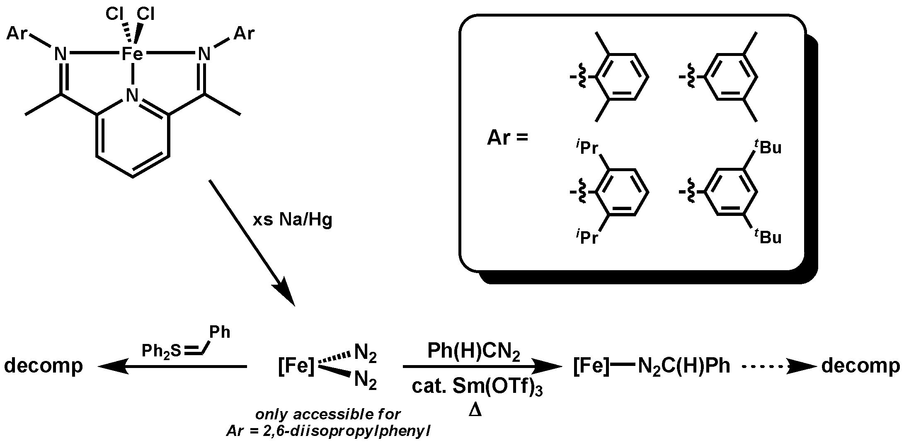
We prepared a variety of pyridyl diimine ligands with varying degrees of steric bulk at the ortho and meta aryl positions. Interaction of the previously reported (^{iPr}PDI)Fe(N₂)₂ with phenyldiazomethane resulted only in formation of the diazo adduct with iron which was stable to heating at 80 °C in C₆D₆ but decomposed in the presence of samarium(III) triflate. Shortly after these preliminary results, our findings about the instability of the proposed (^{iPr}PDI)Fe carbene were confirmed by findings in the Chirik group regarding the decomposition of a purported trimethylsilylmethylidene via 1,2-addition of the isopropyl aryl group across the iron-carbon bond. Sulfur ylides were also utilized as potential carbene transfer reagents, but yielded no tractable products.
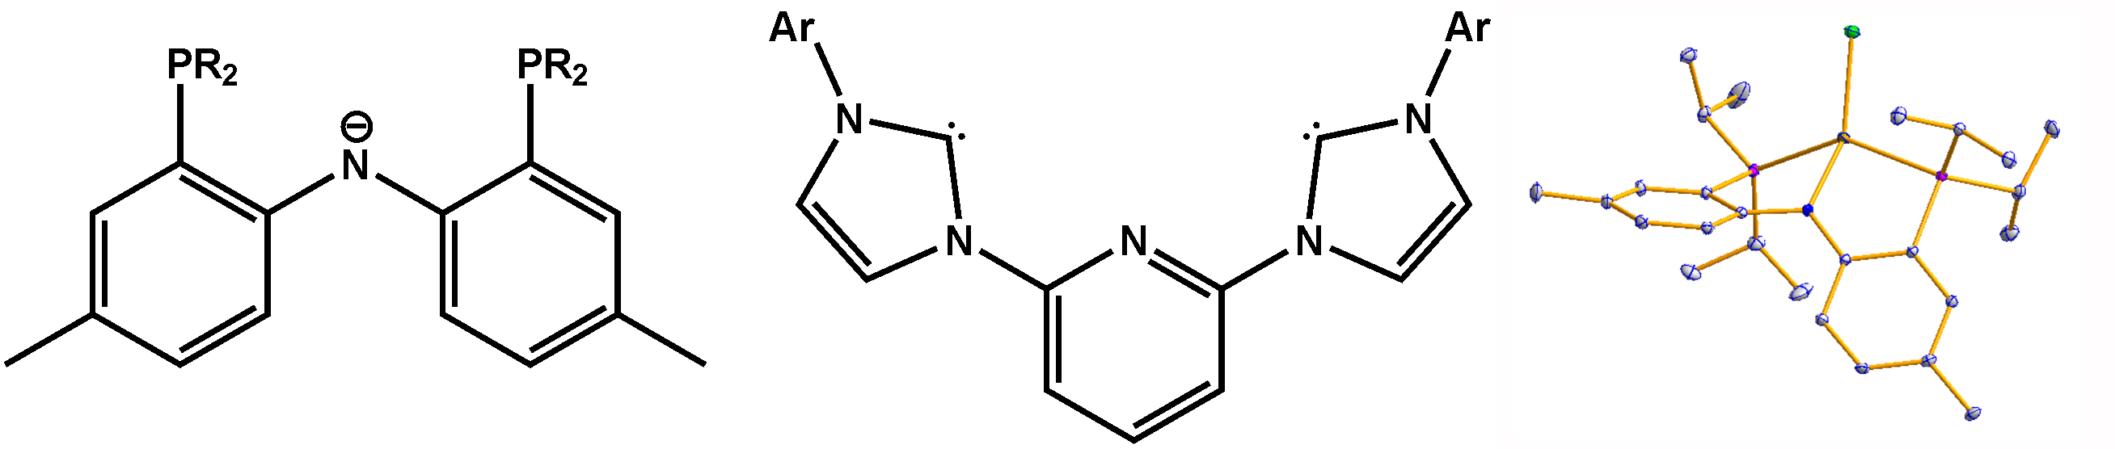
Unfortunately, the 2,6-diisopropylphenyl ligand appears to be finely tuned to support the iron(0) bis(dinitrogen) complex, and all changes that were made to prevent 1,2-addition of ortho aryl substituents also precluded clean reduction of the iron(II) dichloride precursor. Turning away from the Chirik systems, a number of alternative ligand frameworks are being explored. Based on the reported difficulty in reducing the bis(phosphino)pyridine iron complexes in the absence of strong π-accepting ligands, two ligands with delocalized π-systems were identified as promising candidates to support low-valent iron(I) or iron(0) precursors. We have developed methodology for installing the reducing amidophosphine PNP ligand at iron(II) and are focusing our efforts on exploring the reactivity of these PNP⁻ and CNC iron scaffolds.
Cyclic Catalyst Optimization. Motivation for improved cyclic catalyst design is prompted by the observation that our original ring-expansion metathesis polymerization (REMP) catalyst 1 (see Figure 1) displayed slow initiation as well as significant amounts of chain-transfer, which ultimately resulted in cyclic polymers of uncontrolled molecular weights and high PDIs. The objective of our catalyst optimization is to increase initiation rates relative to propagation. In doing so, the polymerization may better resemble a living process, leading to better control over molecular weight and an ability to access cyclic block copolymers. To improve the initiation rates of REMP catalysts, we propose four new catalysts (see
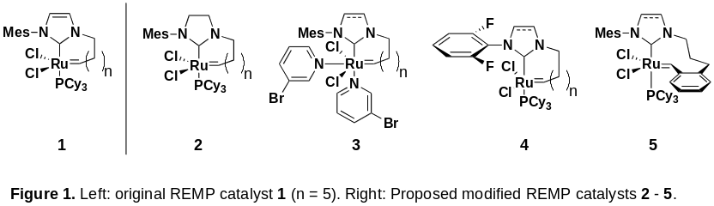
Figure 1). The first modified catalyst (2), features a saturated backbone within the NHC ligand (cf. 1). This structural change has previously been shown to greatly improve initiation rates in related, acyclic catalysts. REMP catalyst 3 takes advantage of initiation rate acceleration resulting from more labile 3-bromopyridine ligands in exchange for a Cy₃P group. Similar Ru-benzylidene catalysts have been prepared and involve only straightforward synthetic endeavors. Importantly, previous generations of catalysts armed with 3-bromopyridine ligands have displayed unprecedented initiation rates in linear polymer formation., Incorporation of a fluoroarene into the NHC ligand (i.e., 4) may also increase catalyst activity. In related catalyst predecessors, increased activity was observed and was attributed to a unique F-Ru interaction. Parallel to the above structural optimizations, we also intend to increase the catalyst stability via incorporation of a benzylidene-based ligand (5). Ru-alkylidene catalysts typically display lower stabilities and slower initiation than benzlidene-containing analogues. Notably, after independently investigating the catalysts in Figure 1, it will be possible to embark on further optimization that targets hybrids of 2 – 5.
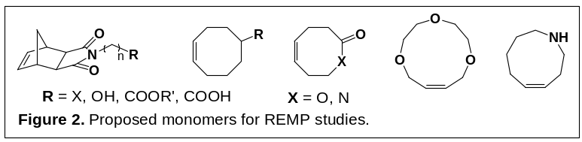 Monomer Functionality. Another objective of our research is to provide a broad library of cyclic polymers with diverse chemical properties. Ultimately, it will be possible to obtain highly functionalized, and specialized, cyclic polymers possessing unique physical and biological properties, and also perform post-polymerization functionalization such as grafting. Examples of monomers are depicted in Figure 2 and may include alcohol, carboxylic acid, activated halide functionalities, as well as PEG, lactone, and lactam architectures. Notably, the combination of a fast initiating catalyst (see above) and a hindered monomer that disfavors chain transfer, such as norbornene, may lead to a “living” system, where sequential addition of different types of monomers will result in cyclic block copolymers.
Narrow disperse cyclic polymers and cyclic block copolymers are believed to present different nanostructures and phase behavior from their linear analogues due to the lack of end groups. Thus, they may lead to novel materials for nanotechnology and molecular engineering. Our immediate objectives involve development and optimization of our cyclic catalyst, and determination of the scope of monomer structure compatibility. Many of the polymer properties will be established through collaborations.
Polyethylenes of different topology
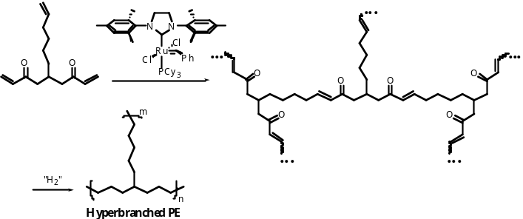
Polyethylene (PE) is one of the simplest and most used polymeric materials. It has served as the basis for many studies that relate structure and function. To develop and test concepts, samples of polyethylene with precise structure and topological control are needed. ROMP provides the tools for the synthesis of three extreme topologies that can be used in a wide array of studies. As discussed above, collaborations have been developed for the physical studies that will be required to fully characterize the structure-property relationships of these materials. Interestingly, the synthesis of cyclic PE is enabled by both the design of a special metathesis catalyst and the judicious choice of monomers (REMP) (see above).
Linear PE can be prepared by (1) ROMP of cyclic olefins with sufficient ring strain or (2) ADMET followed by hydrogenation of the carbon-carbon double bonds along the polymer's backbone. Excellent molecular weight control and relatively narrow PDIs can be achieved with the ROMP of highly strained olefins such as cyclobutene and trans cyclooctene. Unlike industrial high-density PE (HDPE), the PE prepared by olefin metathesis is absolutely linear, with no branching. A convenient route to near monodispersed PE is the ROMP of trans cyclooctene. Routes using this monomer will be fully explored.
The synthesis of hyperbranched PE is enabled by both the choice of catalyst and the design of the monomers. The monomers utilized for hyperbranched polymerization usually possess two different types of functional groups (A and B), which readily react with each other but never react with themselves. Consequently, these AB_{n} monomers are polymerized into hyperbranched structures by one-pot processes. We recently reported a facile route to hyperbranched polymers via acyclic diene metathesis (ADMET). Any molecule functionalized with two or more acrylate groups and one terminal olefin can serve as an AB_{n} monomer when exposed to an imidazolinylidene-based ruthenium olefin metathesis catalyst. This catalyst selectively crosses an acrylate with a terminal alkene, with no acrylate homodimerization. Homodimerization of terminal alkenes does occur, but the newly formed internal alkenes are still very active towards metathesis. Moreover, ADMET of an AB₂ monomer with a purely hydrocarbon skeleton and vinyl ketone functionalities instead of acrylates (thus lacking ester linkages) will yield a polymer which, upon hydrogenation, is a hyperbranched PE. The method allows for precise control of the branch length (by monomer design) and, thus, for further tuning of the material’s properties.

Functional Group Metathesis
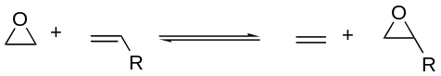
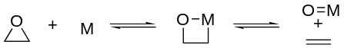
Olefin metathesis is an equilibrium reaction that is composed of two reversible steps: olefin exchange and metallacycle formation. As has been demonstrated, such a situation can allow for reasonably straightforward catalyst design and opens many opportunities for variation. A similar strategy can be considered for other olefin reactions that transfer functionality from a simple olefin precursor to an olefin. The example given below is for an epoxidation reaction. However, similar mechanisms can be drawn for the interconversion of alcohols (water) and olefins and aziridines and olefins. The basic transformation that allows this interconversion is the reversible interconversion of epoxides and metal oxocomplexes. The reaction is known in both directions in stoichiometric reactions. The key will be the discovery of a precisely tuned metal complex that will provide reversibility. As has been demonstrated in olefin metathesis, the reaction can be very successful even if the equilibrium concentration of one of the two species is very low. In a similar way, the interconversion of alcohols and olefins can be considered. In this circumstance, the initial catalysts will be derived from a radical source such as an alkyl peroxide. This radical mechanism is chosen as an illustration since it should lead to the anti-Markovnikov addition of water to an olefin. This mechanism is based on the mechanism of addition of HBr to olefins in the presence of radicals. As has been demonstrated by the lack of anti-Markovinkov addition of HCl and HI in the presence of radical sources, the balancing of the bond strengths is extremely important. Cationic or metal hydride mechanisms can also be considered, although these routes would probably lead to Markovnikov additions.
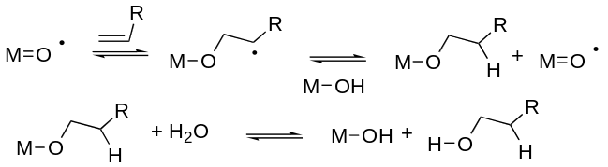
There are models for many of these steps that are irreversible. The challenge is finding the exact metal and ligand system that will provide for an equilibrium among the required intermediates. Computational methods and our understanding of the basic energetics of these processes do not allow a priori construction of an appropriate complex. Consequently, we will resort to screening methods. The Symyx high throughput screening tools available in the Caltech Center for Catalysis and Synthesis will be used to explore a variety of catalysts and reaction conditions to discover hits to be examined in more mechanistic detail to develop appropriate catalysts for the above processes. Key to success is the development of an appropriate starting point. Porphyrins and Salen complexes would appear to be excellent starting points for the epoxidation reaction and some of the hydration transformations. Groves has carried out extensive studies of the related reactions. A wide array of porphyrins with different lateral substitutents and with an array of axial ligands will be studied under a variety of conditions. We already have an array of porphyrins from other studies that have been carried out in our laboratory and arrays of salen complexes are straightforward to prepare. In related studies, palladium complexes related to those that have been reported, but not reproduced, to add water to olefins in an anti-Markovinkov fashion will be examined. Some preliminary leads for hydration catalysts have already been obtained in screens of rhodium halides and palladium salts.
Catalyst Comparison
To compare catalysts for specific applications, numerous and precise kinetic runs under a number of conditions are required. Unfortunately, determination of rates by NMR or by other methods is very time consuming. The Symyx tool that has been developed for rapid screening of catalysts is an excellent alternative tool for the determination of rates with little effort from the researcher. We will do a thorough analysis of rates, lifetimes and selectivities of all the new active catalysts.
We propose to launch a program based on functional group metathesis using high through put screening to find lead complexes. Leads will be followed by complete mechanistic studies.

) Scholl, M.; Ding, S.; Lee, C. W.; Grubbs, R. H. Org. Lett. 1999, 1, 953-956.
) (a) McGuinness, D. S.; Cavell, K. J.; Skelton, B. W.; White, A. H. Organometallics 1999, 18, 1596-1605. (b) Gründemann, S.; Albrecht, M.; Kovacevic, A.; Faller, J. W.; Crabtree, R. H. J. Chem. Soc., Dalton Trans. 2002, 2163-2167. (c) Trnka, T. M.; Morgan, J. P.; Sanford, M. S.; Wilhelm, T. E.; Scholl, M.; Choi, T. -L.; Ding, S.; Day, M. W.; Grubbs, R. H. J. Am. Chem. Soc. 2003, 125, 2546-2558. (d) Fürstner, A.; Seidel, G.; Kremzow, D.; Lehmann, C. W. Organometallics 2003, 22, 907-909. (e) Garrison, J. C.; Youngs, W. J. Chem. Rev. 2005, 105, 3978-4008. (f) Hahn, F. E.; Paas, M.; Le Van, D.; Lügger, T. Angew. Chem., Int. Ed. 2003, 42, 5243-5246.
) (a) Herrmann, W. A.; Köcher, C.; Goossen, L. J.; Artus, G. R. J. Chem.-Eur. J. 1996, 2, 1627-1636. (b) Öfele, K. J. Organomet. Chem. 1968, 12, P42-P43. (c) Méry, D.; Aranzaes, J. R.; Astruc, D. J. Am. Chem. Soc. 2006, 128, 5602-5603.
) Arduengo, A. J. III; Krafczyk, R.; Schmutzler, R. Tetrahedron 1999, 55, 14523-14534.
) Jazzar, R.; Liang, H.; Donnadieu, B.; Bertrand, G. J. Organomet. Chem. 2006, 691, 3201-3205.
) Jazzar, R.; Bourg, J.-B.; Dewhurst, R. D.;Donnadieu, B.; Bertrand, G. J. Org. Chem. 2007, 72, 3492.
) K. Kuhn and R. Grubbs, unpublished results.
) (a) Gao, Y.; Sharpless, K. B. J. Am. Chem. Soc. 1988, 110, 7538-7539. (b) Kim, B. M.; Sharpless, K. B. Tetrahedron Lett. 1989, 30, 655. (c) Oi, R.; Sharpless, K. B. Tetrahedron Lett. 1991, 32, 999. (d) Alonso, M.; Riera, A. Tetrahedron Asymmetry 2005, 16, 3908-3912.
) Trnka, T. M.; Morgan, J. P.; Sanford, M. S.; Wilhelm, T. E.; Scholl, M.; Choi, T.-L.; Ding, S; Day, M. W.; Grubbs, R. H. J. Am. Soc. Chem. 2003, 125, 2546-2558.
) Decomposition modes
) Occhipinti, G.; Bjorsvik H.-R.; Jensen, V. R. J. Am. Soc. Chem., 2006, 128, 6952-6964.
) Small, B. L.; Brookhart, M. J. Am. Chem. Soc. 1998, 120, 7143. Small, B. L.; Brookhart, M.; Bennett, A. M. A. J. Am. Chem. Soc. 1998, 120, 4049. Britovsek, G. J. P.; Bruce, M.; Gibson, V. C.; Kimberley, B. S.; Maddox, P. J.; Mastroianni, S.; McTavish, S. J.; Redshaw, C.; Solan, G. A.; Stromberg, S.; White, A. J. P.; Williams, D. J. J. Am. Chem. Soc. 1999, 121, 8728
) Bart, S. C.; Bowman, A. C.; Lobkovsky, E.; Chirik, P. J. J. Am. Chem. Soc. 2007, 129, 7212. Bart, S. C.; Chlopek, K.; Bill, E.; Bouwkamp, M. W.; Lobkovsky, E.; Neese, F.; Wieghardt, K.; Chirik, P. J. J. Am. Chem. Soc. 2006, 128, 13901. Bart, S. C.; Lobkovsky, E.; Bill, E.; Wieghardt, K.; Chirik, P. J. Inorg. Chem. 2007, 46, 7055. Bouwkamp, M. W.; Lobkovsky, E.; Chirik, P. J. J. Am. Chem. Soc. 2005, 127, 9660.
) Bart, S. C.; Lobkovsky, E.; Chirik, P. J. J. Am. Chem. Soc. 2004, 126, 13794.
) Bart, S. C.; Lobkovsky, E.; Bill, E.; Chirik, P. J. J. Am. Chem. Soc. 2006, 128, 5302.
) Trovitch, R. J.; Lobkovsky, E.; Chirik, P. J. Inorg. Chem. 2006, 45, 7252.
) Fan, L.; Foxman, B. M.; Ozerov, O. V. Organometallics 2004, 23, 326. Liang, L. C.; Lin, J. M.; Hung, C. H. Organometallics 2003, 22, 3007. Danopoulos, A. A.; Tsoureas, N.; Wright, J. A.; Light, M. E. Organometallics 2004, 23, 166. Danopoulos, A. A.; Wright, J. A.; Motherwell, W. B. Chem. Commun. 2005
) “An ‘Endless’ Route to Cyclic Polymers.” Bielawski, C. W.; Benitez, D.; Grubbs, R. H. Science 2002, 297, 2041-2044.
) “Living Ring-Opening Metathesis Polymerization” Bielawski, C. W.; Grubbs, R. H. Prog. Polym. Sci. 2007, 32, 1-29.
) “Mechanism and Activity of Ruthenium Olefin Metathesis Catalysts” Sanford, M. S.; Love, J. A.; Grubbs, R. H. J. Am. Chem. Soc. 2001, 123, 6543-6554.
) “A Practical and Highly Active Ruthenium-Based Catalyst that Effects the Cross Metathesis of Acrylonitrile.” Love, J. A.; Morgan, J. P.; Trnka, T. M.; Grubbs, R. H. Angew. Chem. Int. Ed. 2002, 41, 4035-4037.
) “Controlled Living Ring-Opening-Metathesis Polymerization by a Fast-Initiating Ruthenium Catalyst.” Choi, T.-L.; Grubbs, R. H. Angew. Chem. Int. Ed. 2003, 42, 1743-1746.
) “Rate Acceleration in Olefin Metathesis through a Fluorine-Ruthenium Interaction.” Ritter T.; Day, M. W.; Grubbs, R. H. J. Am. Chem. Soc. 2006, 128, 11768-11769.
) Singh, R.; Czekelius, C.; Schrock, R. Macromolecules, 2006, 39, 1316-1317, Wu, Z.; Grubbs, Macromolecules, 1994, 27, 6700-6703
) Sworen, J.; Wagener, K. Macromolecules, 2007, 40, 4414-4423
) Shea, K.; Kim, J-S. J. Am. Chem. Soc. 1992, 114, 3044-3051, and Walker, R.; Grubbs, R., unpublished results.
) Gorodetskaya, I. A.; Choi, T.-L.; Grubbs, R. H. J. Am. Chem. Soc. 2007, 129, 12672.
) Guan, Z.; Cotts, P. M.; McCord, E. F.; McLain, S. J. Science 1999, 283, 2059
) J. T. Groves, K.H. Ahn, R. Quinn, J. Am. Chem. Soc. 1988, 110, 4217
) P. Romero, W.E. Piers J. Am. Chem. Soc. 2007, 129, 1698-1704
) J. Cuerva, A. Campa, J.5 Justicia, A. Rosales, J. Oller-Lopez, R. Robles, D. Cardenas, E. Bunuel, and J. Oltra, Angew. Chem. Int. Ed. 2006, 45, 5522-5526
) M Sanford, J. T. Groves, Angew. Chem.Int. Ed. 2004, 43, 588-590
) M. Francis, E. Jacobsen, Angew. Chem.Int. Ed. 1999,38, 937-941
) C. Wang, K. Shalyaev, M. Bonchio, T. Carofiglio, J. T. Groves, Inorg. Chem. 2006, 45, 4769
) H. F. Koch, L. A. Girard, D. M. Roundhill Polyhedron 1999, 18, 2275, D. Ramprasad, H. Yue, J. Marsella , Inorg. Chem., 1988, 27, 3151, C. Jensen, W. Trogler, Science 1986, 233, 1069; US patent 4,684,751).
) I. Stewart, D. Anderson and R. Grubbs, unpublished results

